Examination Guide 1-15

Repeating-Pattern Marks

June 2015

I. Background 2

A. Defining Repeating-Pattern Marks 2

B. Identifying Repeating-Pattern Marks 2

II. Drawings, Descriptions, and Specimens for REPEATING-PATTERN MARKS 3

A. Mark Drawing Requirements 3

1. Mark Drawings for Trademarks 3

a. Mark Used on a Single Item Should Be Depicted as it Appears on the Item 3

b. Mark Used in a Similar Manner on Similar Items May Be Depicted as it Appears on One of the Items 3

c. Mark Used on Different Items Will Usually Require Separate Applications Rather than a Swatch-Type Drawing 4

2. Mark Drawings for Service Marks 5

B. Mark Descriptions 6

C. Material Alteration 6

1. Amending the Drawing to Depict a Different Object 6

2. Amending a Swatch-Type Drawing to Show an Object and Vice Versa 7

3. Amending the Drawing to Depict a Different Placement of the Pattern 7

4. Amending Mark Descriptions 7

5. Amendments in Applications Based on Section 44 or Section 66(a) 7

D. Specimens 7

III. Refusals 8

A. Failure-to-Function Refusal – Mark Not Inherently Distinctive 8

1. Inherent Distinctiveness Determination 8

a. Common or Widely Used Pattern 9

b. Pattern Creates a Distinct Commercial Impression Apart from Other Matter 9

c. Nature of Elements in the Repeating Pattern 9

d. Industry Practice 9

e. Type of Product 9

2. Statutory Basis for Refusal 9

3. Response Options 10

B. Failure-to-Function Refusal – Inconsistent Goods or Services 10

1. Statutory Basis for Refusal 11

2. Response Options 11

C. Refusal - Application Seeks Registration of More than One Mark 12

1. Statutory Basis for Refusal 12

2. Response Options 12

D. Applications Based on Section 1(b), Section 44, or Section 66(a) 12

IV. Other Considerations 12

A. Functional Repeating Patterns 12

B. Random Patterns 13

V. Examples 13

A. Registered Repeating-Pattern Marks 13

B. Making Inherent Distinctiveness and Inconsistent Goods/Services Determinations 18

This examination guide clarifies the policies and procedures for examining marks consisting of repeating patterns. The guide addresses the requirements for mark descriptions and specimens of use in applications for repeating-pattern marks. In addition, the guide discusses the drawing requirements for these marks, explaining that, in most cases, the appropriate type of mark drawing is one that shows the particular display and placement of the repeating pattern on a single item. Finally, the guide discusses some considerations for determining whether an applied-for repeating-pattern mark is inherently distinctive; explains the requirement that all of the identified goods or services be consistent with the manner of use depicted in the mark drawing; addresses potential refusals and the relevant response options; and provides examples illustrating some of the concepts covered. This guide supersedes any previous USPTO guidance on this topic.

# Background

## Defining Repeating-Pattern Marks

For the purposes of this examination guide, a repeating-pattern mark is any mark composed of a single repeated element or a repeated combination of designs, numbers, letters, or other characters, forming a pattern that is displayed on the surface of goods, on product packaging, or on materials associated with the advertising or provision of services. The pattern may appear over the entire surface of the relevant item or on just a portion of it.

Repeating-pattern marks are often applied to clothing and fashion accessories, but they also appear on other goods, including furniture,[1] bedding,[2] dinnerware,[3] luggage,[4] paper products,[5] and cleaning implements.[6] In addition, these marks frequently appear on packaging for a variety of goods[7] and have been registered for use in connection with services such as retail stores[8] and travel agencies.[9] For examples of registered repeating-pattern marks, see Part V*.*

As explained in Part III.A, a repeating pattern that is unique when used in connection with the relevant goods or services may be inherently distinctive. However, because of the ornamental and typically nondistinctive nature of repeating patterns, consumers often do not perceive these patterns as source indicators, in which case they may not be registered on the Principal Register without proof of acquired distinctiveness.

## Identifying Repeating-Pattern Marks

In a repeating-pattern mark, the repetition of the mark’s elements is a feature of the mark, which must be appropriately specified in the application. The fact that the specimen shows the mark depicted in the mark drawing being used in a repetitive fashion on the relevant items is not, by itself, a sufficient basis for treating the applied-for mark as a repeating-pattern mark. That is, despite what is shown in the specimen, the applicant might not be seeking a registration in which repetition is a feature of the mark. Accordingly, as in the examples in Part V, there also must be some indication in the mark description or mark drawing to indicate that the mark consists of a repeating pattern.

If the nature of the mark is ambiguous, the examining attorney must seek clarification from the applicant through a Trademark Rule 2.61(b) requirement for information,[10] or by telephone or e-mail communication, as appropriate. Any clarification obtained through informal communication should be recorded in a Note to the File.[11]

# Drawings, Descriptions, and Specimens for REPEATING-PATTERN MARKS

Because repeating-pattern marks differ from conventional marks in how they appear on goods, packaging, and items associated with services, such as signage or promotional materials, special considerations apply to the drawings, descriptions, and specimens for these marks.

## Mark Drawing Requirements

The mark drawing for a repeating-pattern mark must be a substantially exact representation of the mark.[12] The impression created by a repeating pattern may change depending on a number of factors, including the nature of the pattern and the item it appears on, the particular placement of the pattern on the item, and the size and scale of the elements in the pattern as applied. Thus, in most cases, to accurately depict the mark, a drawing showing the particular manner of display and placement of the repeating pattern is necessary.

As explained below, a swatch-type drawing—one that does not show the particular placement of the mark but instead consists of a sample of the repeating pattern displayed within a rectangle—is acceptable only under certain circumstances.

### Mark Drawings for Trademarks

#### Mark Used on a Single Item Should Be Depicted as it Appears on the Item

The drawing for a repeating-pattern mark applied in a particular manner to a single item must depict the pattern as it appears on the item. Thus, if the pattern appears only on a portion of the item, the drawing must show the pattern’s placement on that portion. If the pattern appears over the entire surface of the item, the drawing must depict the pattern accordingly. The shape of the item must appear in broken lines to indicate that it is not claimed as part of the mark.[13] If the drawing shows the item in solid lines, the USPTO will interpret the drawing as indicating that the proposed mark is a composite mark consisting of both the repeating pattern and the shape of the item it is applied to.[14]

If it is unclear what portions of the drawing are claimed as part of the mark, the examining attorney must seek clarification from the applicant through a Trademark Rule 2.61(b) requirement for information,[15] or by telephone or e-mail communication, as appropriate.[16] Based on that clarification, the examining attorney must also require the appropriate amendments to the mark drawing and mark description.

See Part III.B regarding the relevant examination procedures when an application identifies goods that are inconsistent with the depiction of the mark in the mark drawing.

#### Mark Used in a Similar Manner on Similar Items May Be Depicted as it Appears on One of the Items

If the repeating pattern will be applied to multiple goods, a drawing showing the pattern’s placement on one of the goods is appropriate if all of the identified goods are similar in form and function, and the mark will appear in a similar manner on all of the goods. Under these circumstances, a depiction of one of the goods may be considered a substantially exact representation of the mark as used on all of the goods. For example, if a repeating pattern is used in a similar manner on similarly shaped purses of various sizes, a drawing showing the repeating pattern on one version of the purses (shown in broken lines) would be acceptable. Another example is a repeating-pattern mark that is applied in the same manner to the handles of forks, spoons, and knives. In that case, a drawing that depicts the mark on a spoon (or fork or knife) shown in broken lines would be acceptable.

Likewise, if the repeating-pattern mark will appear in a similar manner on various sizes of similarly shaped product packaging, then a drawing showing the mark appearing on one version of the packaging depicted in broken lines is acceptable.

#### Mark Used on Different Items Will Usually Require Separate Applications Rather than a Swatch-Type Drawing

Sometimes, an applicant uses, or intends to use, a repeating-pattern mark in various ways on the same or similar items, or in similar or different ways on a variety of items. In those circumstances, a mark drawing depicting the mark appearing on a particular item will not accurately depict the mark and the nature of its use. Previously, to address this issue, applicants have submitted swatch-type drawings, which do not show a particular placement of the mark, but instead consist of a sample of the repeating pattern within a rectangle.

However, these swatch-type drawings usually will not adequately depict the nature of the mark for which registration is sought, because the impression created by a repeating pattern may change depending on the nature of the pattern, the type of item the pattern appears on, the particular placement of the pattern on that item, and the size and scale of the elements in the pattern as applied. Accordingly, these swatch-type drawings could encompass multiple versions of the mark, each of which may convey a different commercial impression. Therefore, these swatch-type mark drawings are usually not appropriate for repeating-pattern marks, and examining attorneys generally should not accept them.

However, a swatch-type drawing is acceptable if the applicant shows with sufficient evidence that (1) the applied-for mark is actually used, or will be used, in various ways or on a variety of different items, but (2) it will nonetheless be perceived as a source indicator and create the same commercial impression across all uses.

The evidence of variable use need not show every use of the repeated pattern on the relevant items, but it should provide a reasonable basis for concluding that the use of the mark in connection with the identified goods or services is so varied that a single depiction of the mark on a particular item would not accurately reflect the nature of the mark. For applications not based on use in commerce, the evidence should indicate the applicant’s intention to use the mark in various ways or on a variety of different items. This may include declarations, marketing materials, and other similar matter.

The evidence as to the commercial impression must be substantial and must establish that the pattern will be perceived as a source indicator and create the same commercial impression in the minds of consumers. Relevant evidence may include consumer declarations; advertisements or other materials showing various instances of the pattern being used together in one place (e.g., a single advertisement that shows the pattern being used in various ways on various goods, but nonetheless projecting the same commercial impression); sales figures relevant to the various items featuring the pattern; and any other evidence of the applicant’s efforts to promote the various uses of the repeating pattern as a single source indicator for the relevant goods or services, including “look-for”-type evidence. Although the evidence listed above is similar to evidence that would be submitted in support of an acquired distinctiveness claim, here the examining attorney’s determination is focused not on whether the mark has acquired distinctiveness but on whether the use or intended use of the mark, and the likely consumer perception of it, satisfy the specified conditions for acceptance of a swatch-type drawing. That said, even if these conditions are satisfied, an examining attorney must also consider the applied-for mark’s distinctiveness, because a swatch drawing is not appropriate unless the applied-for mark is inherently distinctive or has acquired distinctiveness.

For a recent example of the type and amount of evidence that might support a swatch-type drawing, see the evidence submitted in the application for a repeating-pattern mark that ultimately registered as U.S. Registration No. 4683371. The evidence, which was submitted in support of a claim of acquired distinctiveness, consisted of the following: a statement that the applied-for repeating-pattern mark had been used for over ten years on hangtags, packaging, promotional materials, and across various product categories; evidence showing that it is a common practice in the fashion industry for fashion brands to develop signature patterns; examples of pattern designs in the fashion industry that have become well-recognized as source indicators; news articles and website excerpts touting the applied-for repeating pattern mark in connection with the applicant; examples of the mark in use on packaging, shopping bags, hangtags, and promotional materials, which, according to the applicant, resulted in the mark “creating a distinct impression across the entire brand and becoming associated with that brand as an indication of source”; examples of various products featuring the mark; a declaration indicating substantial sales of products, packaging, or hangtags featuring the applied-for mark, as well as significant marketing expenditures relating to promotion of products featuring the repeating pattern. While this evidence was submitted to support a claim of acquired distinctiveness, it is also the kind of evidence that may support the submission of a swatch-type drawing, because it shows that the repeating-pattern mark is used in various ways on a variety of items and that the repeating pattern would be perceived as a source indicator and create in the minds of consumers the same commercial impression across that pattern’s various uses.

If the applicant has submitted a swatch-type drawing but the evidence of record does not establish that a swatch-type drawing is appropriate, the examining attorney must refuse registration on the ground that the application seeks registration of more than one mark. *See* Part III.C.

### Mark Drawings for Service Marks

Repeating-pattern marks are used as service marks in a variety of ways. For instance, a repeating-pattern mark could be displayed on a retail store’s façade, on a customer loyalty card, on advertising materials, or on shopping bags.

If a repeating pattern appears on elements in a service setting in a manner that makes a single commercial impression, such as a pattern that is displayed on the various architectural features or other fixtures of a retail outlet, a drawing of the setting should be submitted, along with a detailed description of the mark that specifies the location and manner of use of the repeating pattern.[17] The mark drawing must depict in broken lines those elements of the environment that display the repeating pattern but are not claimed as a feature of the mark.

Otherwise, if the mark is used on a particular item, or is used in a similar manner on multiple items that are similar in form and function, and can thus be adequately represented by a depiction of a single item, a drawing consisting of the mark appearing on a single item is appropriate.

The conditions for accepting a swatch-type drawing for repeating-pattern marks used in connection with services are the same as those explained in Part II.A.1.c.

## Mark Descriptions

The mark description must accurately describe the mark.[18] Thus, the description for a repeating-pattern mark must indicate that the mark consists of a pattern. Although the description must identify the various elements of the pattern, it is not necessary to describe their exact placement within the pattern; it is sufficient for the description to generally characterize the elements and indicate that they are repeated.[19]

In addition, the description must specify how the pattern will appear on the relevant items. Thus, if the pattern is applied only to a portion of the relevant goods, packaging, or other items, the description must specify that portion. If the pattern is repeated over the entire surface of the relevant items, the description must say so. And, if the pattern is displayed in various ways on the relevant items (*see* Part II.A.1.c), then the mark description must include wording to that effect. For example, in the latter instance, the following description would be acceptable: “The mark consists of a repeating pattern of stars and circles used on various portions of the product packaging for the identified goods.”

The mark description should also describe any portions of the mark that are shown in broken lines and thus are not claimed as a feature of the mark.[20] For repeating patterns featuring color, the application must include an appropriate color claim and the description must indicate where the claimed colors appear.[21]

The mark description for a repeating-pattern mark must always be printed on the registration certificate.[22]

## Material Alteration

### Amending the Drawing to Depict a Different Object

Generally, when the original mark drawing depicts the repeating pattern appearing on a particular object, amending the drawing to show the pattern appearing on a significantly different object (i.e., an object that is not substantially similar in shape) will be considered a material alteration. Thus, if the original mark drawing shows the repeating pattern appearing on the outer surface of a purse, for example, it may not be amended to show the mark appearing on the handle of a walking cane.

However, if the mark will appear in a similar manner on similar items, so that a depiction of only one of the items is still a substantially exact representation of the mark as used on all of the items, the applicant may amend the drawing from a depiction of one of the items to a depiction of another one of the items, assuming the shape of the items is not claimed as a feature of the mark and the specimen of use or foreign registration certificate supports the amendment.[23] For instance, it would not be a material alteration to amend a drawing that shows the pattern appearing on the handle of a spoon shown in broken lines to show the pattern on the handle of a fork shown in broken lines. Of course, any item depicted in the mark drawing must be consistent with the identification of goods or services. *See* Part III.B.

### Amending a Swatch-Type Drawing to Show an Object and Vice Versa

When the original drawing is a swatch-type drawing showing the elements of the pattern within a square, rectangle, or other generic geometric shape, the drawing may be amended to show the pattern appearing on a particular item, if necessary and otherwise appropriate.[24] However, amending from a mark drawing showing the pattern on a particular object to a swatch-type drawing usually will be a material alteration, especially when the elements comprising the pattern are nondistinctive.

### Amending the Drawing to Depict a Different Placement of the Pattern

When the original mark drawing shows the repeating pattern displayed in a particular manner on an object, amending the drawing to show the pattern being displayed in a significantly different manner on the same object may be a material alteration. For instance, a mark drawing that shows the repeating pattern on the outer bill of a cap may not be amended to show the pattern on the inner lining of the cap. However, a minor change to the placement of a repeating pattern on an object should not be considered a material alteration.

### Amending Mark Descriptions

An applicant may not amend a mark description if the amendment would describe a materially different mark than what was depicted in the original mark drawing.[25]

For applications in which the original mark drawing is a swatch-type drawing and the original mark description indicates that the pattern is used a variety of ways, an applicant may amend the mark description to indicate that the pattern appears in a particular manner on a particular item, in accordance with a corresponding drawing amendment. These amendments are not considered material alterations. In these instances, the applicant may also need to amend the identification of goods or services to delete any items that are inconsistent with the mark drawing. *See* Part III.B.

### Amendments in Applications Based on Section 44 or Section 66(a)

For applications based on Section 44 or Section 66(a), any amendments must conform to the rules and procedures governing these types of applications.[26]

## Specimens

As with other types of marks, the specimen of use for a repeating-pattern mark must show use of the mark as depicted in the mark drawing and described in the mark description.

When a repeating pattern is applied to a single item, and the drawing thus depicts the repeating pattern on that item (*see* Part II.A), the specimen should show the pattern displayed on the same item or a substantially similar item. In addition, the placement of the pattern on the object in the specimen should be consistent with the placement as depicted in the drawing and specified in the description.

When a repeating pattern is applied in the same manner to similar items and thus a drawing depicting one of the items is appropriate (*see* Part II.A), the specimen of use need not show the exact same item that is depicted in the mark drawing, assuming the shape of the item in the drawing is not claimed as a feature of the mark. However, the object shown in the specimen must be sufficiently similar to the item in the drawing, such that the drawing is a substantially exact representation of the mark as actually used. *See* Part II.A. In addition, if the mark is applied to goods, the good shown in the specimen must be encompassed by the identification of goods. Thus, if the identified goods are spoons, forks, and knives, and the mark drawing shows the repeating pattern appearing on the handle of a spoon shown in broken lines, a specimen showing the same pattern in the same manner on the handle of a fork would be acceptable. See Part III.B for a discussion of the relevant examination procedures when the identified goods or services are inconsistent with the mark drawing.

When the mark drawing is a swatch-type drawing, and the examining attorney has determined that it is appropriate (*see* Part II.A.1.c), a specimen showing the pattern appearing on a particular object should be considered to match the drawing if the overall commercial impression created by the pattern is the same.

As noted in Part I.B, the fact that the specimen shows the mark depicted in the mark drawing being used in a repetitive fashion on the relevant items is not, by itself, a sufficient basis for treating the applied-for mark as a repeating-pattern mark. There must be some indication in the mark description or mark drawing to indicate that the mark consists of a repeating pattern.

Finally, if necessary, examining attorneys may require additional specimens to determine whether the applied-for mark functions as a trademark or service mark for all of the identified goods or services.[27] For example, additional specimens may be necessary when the identified goods include items that are significantly different from the goods shown in the originally submitted specimen, such that it is not clear how the mark is used on all of the goods.

# Refusals

## Failure-to-Function Refusal – Mark Not Inherently Distinctive

The USPTO will not register an applied-for mark unless it functions as a mark.[28] That is, the mark must serve as an indicator of the source of the goods or services, identifying and distinguishing them from those of others.[29] Not every designation that a party places on goods or packaging, or uses in connection with services, is an inherently distinctive source indicator, regardless of the party’s intentions when adopting the designation.[30] And some designations are not capable of serving as a source indicator.[31] Thus, the examining attorney must determine whether an applied-for repeating-pattern mark actually functions as a trademark or service mark by reviewing the available evidence, including the specimen and any other materials of record.[32]

### Inherent Distinctiveness Determination

Because repeating patterns often serve an ornamental function in various contexts, they are often not inherently distinctive when applied to goods, packaging, or materials associated with services. Instead, consumers may perceive these patterns as nothing more than ornamentation or background matter serving no source-indicating function. Thus, determining whether a repeating-pattern mark is inherently distinctive and functions as a source indicator involves considering the impression created when the mark is used in connection with the identified goods or services.[33]

Relevant considerations include the following:

#### Common or Widely Used Pattern

Evidence showing that the repeating pattern in the applied-for mark is similar to, or a mere refinement or variation of, a common pattern (such as a houndstooth or gingham check pattern) or a pattern that is widely used on the relevant items, may support the conclusion that the applied-for mark is not inherently distinctive.[34] On the other hand, if the nature of the repeating pattern is unique or unusual as applied to the relevant items, a finding of inherent distinctiveness may be appropriate.[35]

However, the mere fact that the applicant is the only user of the particular repeating pattern is not dispositive as to the inherent distinctiveness of a mark featuring that pattern.[36] The examining attorney must weigh this factor together with any other relevant factors.

#### Pattern Creates a Distinct Commercial Impression Apart from Other Matter

The examining attorney should consider whether the pattern creates a commercial impression distinct from any wording or other matter that may also appear on the relevant items.[37] If so, this weighs in favor of finding the pattern inherently distinctive.

#### Nature of Elements in the Repeating Pattern

If a repeating-pattern mark contains an element, such as arbitrary wording, which would be perceived as a source indicator if it were to appear by itself, then the relevant consumers may be more likely to perceive the repeating pattern as a source indicator.[38]

#### Industry Practice

Purchasers are unlikely to view a repeating-pattern mark as an indicator of source if the relevant industry practice is to use repeating patterns in an ornamental fashion with the relevant goods or services. However, if, because of common industry practice, consumers have come to view repeating patterns on the surface of the relevant goods, packaging, or other materials as an indicator of source, and the applied-for mark is more than common background matter, then a finding that the mark is inherently distinctive may be appropriate.

#### Type of Product

The type of item the mark is applied to affects whether consumers perceive the repeating pattern as a mark rather than merely as ornamental or other nondistinctive matter. For example, when repeating patterns appear on items such as clothing, curtains, pillows, bedding, carpet, furniture, and stationery, the patterns are likely to be perceived as decoration because those types of goods are typically purchased or used, at least in part, for their aesthetic appeal. On the other hand, if the type of item the mark is applied to does not usually feature decorative matter, or is not usually purchased or used for its decorative features, like power tools, industrial machinery, or surgical equipment, a repeating pattern may be more likely to be perceived as a source indicator.

### Statutory Basis for Refusal

When the applicant has sought registration of a repeating-pattern mark on the Principal Register without claiming acquired distinctiveness, and the examining attorney determines that the mark is not inherently distinctive, registration must be refused on the ground that the mark fails to function as a source indicator, citing Trademark Act §§1, 2, and 45[39] for trademarks and §§1, 2, 3, and 45[40] for service marks. The examining attorney must explain the specific reasons for the refusal and provide relevant supporting evidence.[41]

If registration is sought on the Supplemental Register, but the examining attorney determines that the mark is incapable of serving as a source indicator, registration must be refused on that ground under Trademark Act §§23 and 45.[42]

### Response Options

If an applied-for mark is capable of serving as a source indicator, the applicant may respond to the refusal by submitting a substitute specimen showing use of the mark as a trademark or service mark, amending to the Supplemental Register, or claiming acquired distinctiveness under Trademark Act Section 2(f), if otherwise appropriate. For repeating-pattern marks that are capable of serving as source indicators but are not inherently distinctive, evidence of five years’ use, by itself, is insufficient to show acquired distinctiveness.[43] That is, actual evidence showing that consumers have come to recognize the applied-for mark as a source indicator will be required to establish acquired distinctiveness.[44]

Furthermore, for repeating-pattern marks used on goods, any showing of acquired distinctiveness must be made with respect to all of the identified goods for which the examining attorney has determined the mark is not inherently distinctive. For repeating-pattern marks used in connection with services, the evidence of acquired distinctiveness must establish that the mark, as used on all of the relevant items, has come to be perceived as a source indicator for the identified services.

See TMEP §[816](http://tmep.uspto.gov/RDMS/detail/manual/TMEP/current/TMEP-800d1e2673.xml) regarding amendment to the Supplemental Register and TMEP §§[1212-1212.10](http://tmep.uspto.gov/RDMS/detail/manual/TMEP/current/TMEP-1200d1e10316.xml) regarding claims of acquired distinctiveness.

The applicant may also submit evidence of secondary source to establish that a repeating-pattern mark primarily serves a source-indicating function rather than merely serving as ornamentation. As discussed in TMEP §[1202.03(c)](http://tmep.uspto.gov/RDMS/detail/manual/TMEP/current/TMEP-1200d1e1773.xml), there are a number of acceptable types of evidence for showing secondary source, such as proof of ownership of a use-based U.S. registration on the Principal Register for the same mark covering other goods or services. However, evidence of a series of ornamental uses of a repeating-pattern mark on various items will not establish that the proposed mark functions as an indicator of secondary source; use as a trademark or service mark for the other goods or services must be shown.[45]

## Failure-to-Function Refusal – Inconsistent Goods or Services

As explained in Part II.A, if the repeating-pattern mark is applied to a particular portion of multiple items that are similar in form and function, it is acceptable for the mark drawing to depict only one of the items. When the mark drawing shows the repeating pattern appearing on an item, the examining attorney must determine whether all of the identified goods or services are consistent with the item depicted, such that the mark shown accurately reflects how the mark appears on all of the identified goods and services and could actually serve as a source indicator for them.

Consider, for instance, an application that depicts the mark as a repeating pattern appearing on the bill of a baseball cap shown in broken lines, but that identifies the goods as baseball caps, shoes, eyeglasses, and purses. While the cap is not part of the mark, the drawing nonetheless limits the mark to the particular manner of use shown. Thus, the identified baseball caps are consistent with the drawing, but the identified shoes, eyeglasses, and purses are not, because the mark obviously cannot be applied to those goods in the manner depicted in the mark drawing. See Part II.C regarding the amendment of mark drawings. If, on the other hand, the drawing depicts a repeating pattern applied to the handle of a hand rake, any other similar type of implement with a handle that is listed in the identification of goods should be considered to be consistent with the mark drawing.

If the mark drawing shows the repeating-pattern mark appearing on packaging for goods, the identified goods should be considered consistent with the drawing if they could be sold in the packaging shown. For instance, if the packaging shown is a bottle, then goods that are not normally packaged in a bottle should be considered inconsistent with the nature of the mark as depicted in the drawing, assuming there is no evidence that the applicant’s goods actually are packaged in that manner.

The fact that an application identifies services, but contains a mark drawing showing the mark applied to a particular object does not necessarily raise an issue of inconsistency. Marks of this nature may function as source indicators for services. For example, a repeating pattern applied in a particular manner to the exterior of an airplane could be perceived as a source indicator for airline transportation services.[46] However, if the application identifies both goods and services, the examining attorney must consider whether the mark shown in the drawing could actually function as both a trademark for the identified goods and a service mark for the identified services.

### Statutory Basis for Refusal

If the examining attorney determines that any of the identified goods or services are inconsistent with the mark drawing, the examining attorney must refuse registration as to those goods or services on the ground that the mark, as depicted in the drawing, fails to function as a mark for them.[47] The statutory bases for the refusal are Trademark Act §§1, 2, and 45 for trademarks and §§1, 2, 3, and 45 for service marks.

### Response Options

The applicant may overcome the refusal by deleting the inconsistent goods or services, or by submitting evidence that the mark, as depicted in the drawing, does in fact function as a mark for the relevant goods or services. In most instances, the applicant will be unable to overcome the refusal by amending the drawing to cover all of the identified goods or services because it will be impossible to do so using a single depiction of the mark and the necessary changes are likely to result in a material alteration of the original mark drawing. *See* Part II.C. In addition, dividing out the inconsistent goods or services typically is not an appropriate response option in these cases because the mark drawing in the child application would need to depict an essentially different mark that would be a material alteration of the original mark drawing.

The determination of whether all of the identified goods or services are consistent with the mark drawing is distinct from the determination of whether the drawing agrees with the specimen of record. *See* Part II.D. Thus, if the application contains specimens showing that the mark drawing is not a substantially exact representation of the mark as used on the goods or packaging, or in connection with the services, the examining attorney must also issue any applicable requirement or refusal on that basis.[48]

## Refusal - Application Seeks Registration of More than One Mark

As explained in Part II.A.1.c, a swatch-type drawing is acceptable only if the applicant has submitted sufficient evidence to establish that the mark is applied to various items but that these various uses of the repeating pattern nonetheless create the same commercial impression.

### Statutory Basis for Refusal

In the absence of the evidentiary showing discussed in Part II.A.1.c, a swatch-type drawing is deemed to encompass numerous versions of the mark, each of which may create a different commercial impression, and thus the examining attorney must refuse registration of the applied-for mark under Trademark Act Sections 1 and 45,[49] on the ground that the application seeks registration of more than one mark.[50]

### Response Options

In response to this refusal, the applicant may amend the swatch-type drawing to depict the mark on a particular item; amend the mark description to describe the placement of the mark on that item; and, if necessary, amend the identification to delete any goods or services that are inconsistent with the mark drawing (*see* Part III.B).

## Applications Based on Section 1(b), Section 44, or Section 66(a)

The refusals discussed above may also apply to applications based on §1(b), §44, or §66(a) if the information in the application or any other available evidence indicates that the applied-for mark fails to function as a trademark or service mark;[51] that the identification includes goods or services that are inconsistent with the mark as depicted in the mark drawing;[52] or that the application seeks registration of more than one mark.

For §1(b) applications, if the examining attorney anticipates issuing a failure-to-function refusal once an allegation of use is filed, the examining attorney should advise the applicant of the potential refusal if otherwise issuing an Office action.[53] However, failure to provide an advisory does not preclude the examining attorney from subsequently issuing a refusal.[54]

With respect to applications based on §44 or §66(a), examining attorneys must adhere to the relevant rules and procedures governing these types of applications, including those pertaining to drawing amendments and acceptable response options.[55]

# Other Considerations

## Functional Repeating Patterns

It is possible, although rare, that a repeating pattern applied to the surface of an item will serve a functional purpose. This could be a utilitarian function, which is essential to the use of the item or affects the cost or quality of the item,[56] or an aesthetic function, which does not have a truly utilitarian function in terms of the item’s use or performance but nonetheless provides a real and significant competitive advantage.[57] For example, a repeating pattern could function as camouflage for a product that requires concealment (utilitarian functionality). Or a repeating pattern could make a product more aesthetically desirable, beyond mere ornamentation, by allowing the product to be visually coordinated with a variety of other related items (aesthetic functionality).[58] If the available evidence supports the conclusion that an applied-for repeating-pattern mark is functional, the examining attorney must refuse registration accordingly. See TMEP §§[1202.02(a)-1202.02(a)(vii)](http://tmep.uspto.gov/RDMS/detail/manual/TMEP/current/TMEP-1200d1e873.xml) regarding functionality and the procedures for refusing registration.

## Random Patterns

The guidance set forth above also generally applies to marks consisting of random or fractal[59] patterns, i.e., patterns in which the relevant elements are not repeated in a set or easily recognized way. However, examining attorneys must carefully review the mark drawing, mark description, and specimen of use for this type of mark to ensure not only that the application accurately depicts and describes the mark, but also that the mark creates the impression of a single mark.

# Examples

## Registered Repeating-Pattern Marks

**(1) U.S. Registration No. 3826587 (Supplemental Register)**

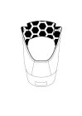

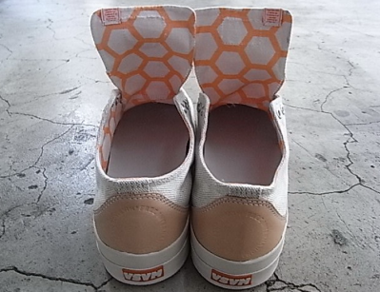

**Mark**

**Specimen**

**Mark Description:** “The mark consists of a repeating pattern of hexagonal shapes printed or stitched on the inner lining of shoe uppers. The matter shown in broken or dotted lines is not part of the mark and serves only to show the position or placement of the mark on the goods.”

**Goods:** Shoes, in International Class 25.

**Note:** The examining attorney initially refused the mark on the ground that it is merely ornamental; the applicant overcame the refusal by amending the application to seek registration on the Supplemental Register. Note also that, although the shape of the shoe in the drawing differs slightly from the shape of the shoe in the specimen, the drawing is a substantially exact representation of the mark as used on the goods.

**(2) U.S. Registration No. 3679828 (Principal Register – §2(f))**

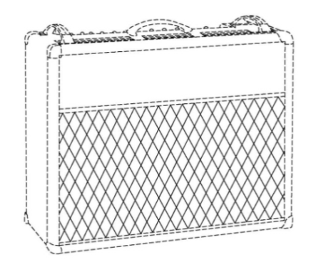 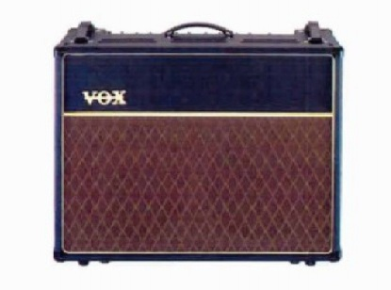

**Specimen**

**Mark**

**Mark Description:** “The mark consists of a repetitive diamond pattern on the cloth speaker grill of a musical instrument amplifier. The dotted lines shown on the drawing are for purposes of positioning only and do not comprise a feature of the mark.”

**Goods:** Musical instrument amplifiers, in International Class 9.

**Note:** The applicant submitted a large amount of evidence to establish that the applied-for mark had acquired distinctiveness as a source indicator, including samples of marketing materials, excerpts from publications, and numerous consumer declarations.

**(3) U.S. Registration No. 3342382 (Principal Register - Cancelled)**

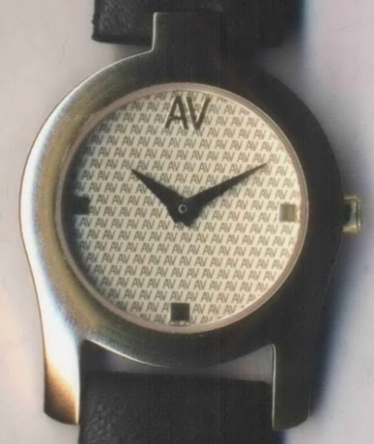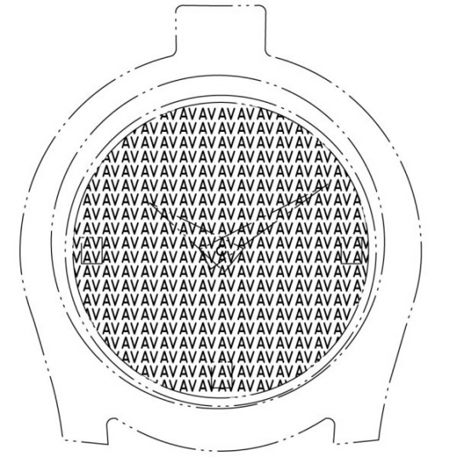

**Mark**

**Specimen**

**Mark**

**Mark Description:** “The mark consists of a repeating pattern of "AV" on the face of a watch.”

**Goods:** Watches, in International Class 14.

**Note:** Themark drawing shows the outline of the watch in broken lines, but the mark description does not specify the meaning of the broken lines. Under the procedures set forth in this guide, marks containing broken lines must indicate the significance of the lines (e.g., that they indicate matter that is not part of the mark).

**(4) U.S. Registration No. 4100365 (Supplemental Register)**

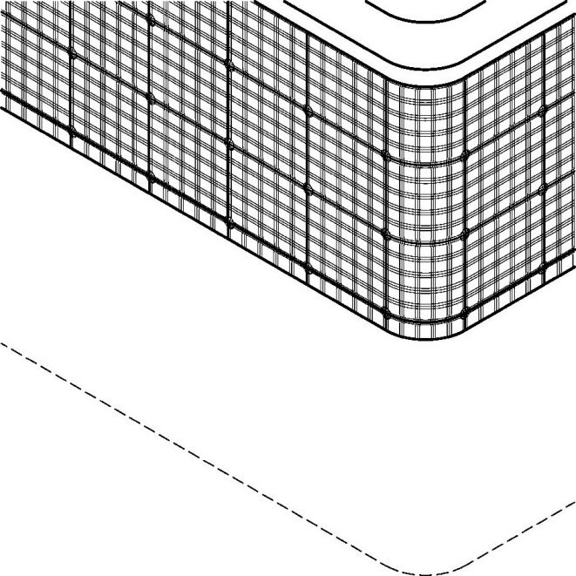

**Mark**

**Mark Description:** “The mark consists of a plaid design located on and covering the entire perimeter of the side border of a mattress, the plaid design comprising a repeat pattern no larger than approximately 1 to 1.6 inches in both its horizontal and vertical dimensions. The matter shown in dotted lines is not part of the mark but merely serves to show the placement of the mark on the goods.”

**Goods:** Mattresses, in International Class 20.

**Note:** Although the entire shape in the mark drawing here is not depicted in broken lines, as indicated in Part II.A.1.a, broken lines must be used to indicate the shape of the item depicted if it is not claimed as part of the mark.

**(5) U.S. Registration No. 1251171 (Principal Register)**

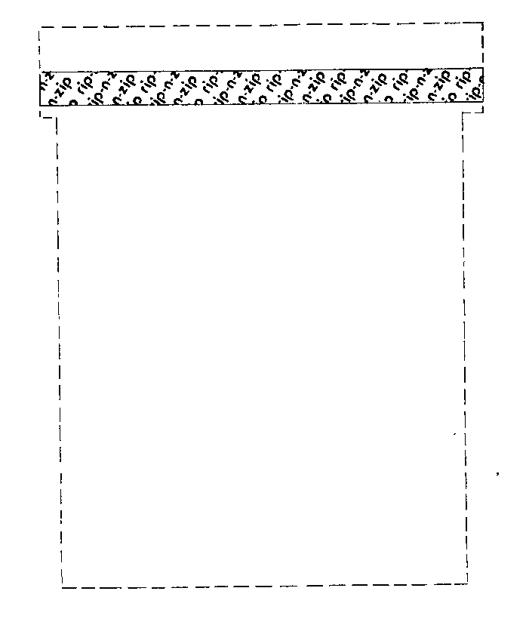

**Mark**

**Mark Description:** “The mark consists of a design showing the words "Rip-N-Zip" repeated in a diagonal pattern along a strip extending across the upper portion of the multiwall bags.”

**Goods:** “Reclosable Multiwall Bags”

**Note:** Themark drawing shows the outline of the goods in broken lines, but the mark description does not specify the meaning of the broken lines. Under the procedures set forth in this guide, marks containing broken lines must indicate the significance of the lines (e.g., that they indicate matter that is not part of the mark).

**(6) U.S. Registration No. 2963354 (Principal Register)**

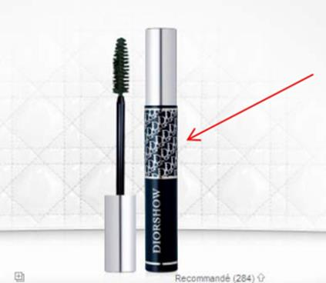

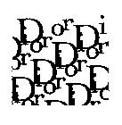

**Specimen**

**Mark**

**Goods:** Perfumery; cosmetics, in International Class 3.

**Note:** Here, the repeating pattern is not a common, widely used pattern, but is instead composed of a stylized depiction of the wording DIOR. Furthermore, the pattern is placed only on part of the goods, in a place where a trademark might appear. Although a repeated pattern often produces an ornamental effect, the repeated element here is highly distinctive and could serve as a source indicator if presented in a single instance, rather than being repeated. Accordingly, the mark is, as used on the goods, inherently distinctive. *See* Part III.A.

Although this registration does not include a mark description,the policies set forth in this guide require a mark description describing the elements that appear in the mark and indicating that they are repeated. In addition, to submit a swatch-type drawing like the one shown here, the applicant must satisfy the requirements described in Part II.A.1.c. Otherwise, a drawing showing placement on the relevant item is required.

## Making Inherent Distinctiveness and Inconsistent Goods/Services Determinations

**Mark**

This example was created for the purpose of discussing inherent distinctiveness and the requirement that the identified goods or services be consistent with the mark drawing.

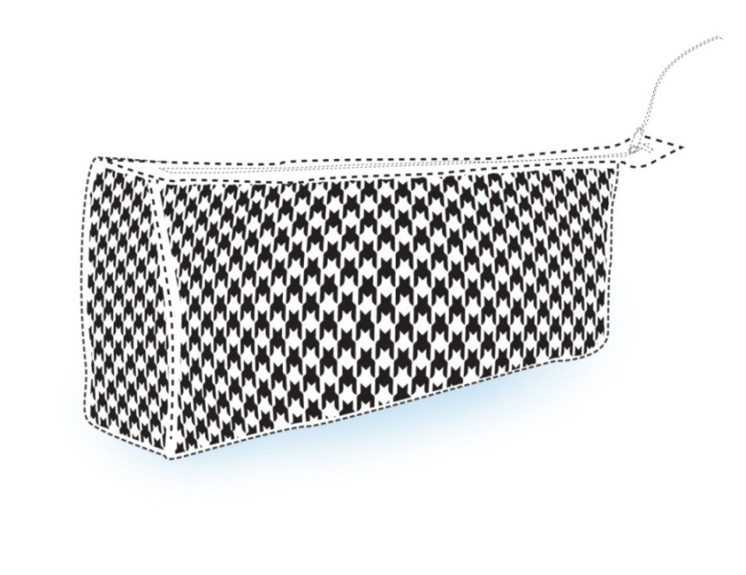

**Mark**

**Mark Description:** The mark consists of a repeated houndstooth pattern applied to the entire exterior surface of the side and end panels of a handbag. The matter shown in broken lines is not part of the mark and serves only to show the placement of the mark on the goods.

**Goods:** Handbags; purses; walking canes, in International Class 18.

**Analysis:** Although source-indicating matter is often displayed in a repetitive manner on the surface of handbags and purses, here the applied-for mark consists of a common pattern, houndstooth, which is widely used on clothing, fashion accessories, household items, and many other goods. There is nothing unusual or distinctive about the manner in which this common pattern is displayed or placed, and thus the pattern will likely be perceived as purely ornamental. Therefore, the applied-for mark is not inherently distinctive and does not function as a source indicator for the goods. *See* Part III.A.

In addition, some of the identified goods are inconsistent with the mark drawing. While the handbag shown in the drawing is not part of the mark, the drawing nonetheless limits the mark to the particular manner of use shown. The mark could be applied in the manner shown to handbags and purses, but not walking canes. Therefore, it is appropriate to refuse registration of the mark as to “walking canes” on the ground that the mark, as depicted in the drawing, fails to function as a mark for those goods. *See* Part III.B.

**Note:** Although the pattern shown is not distinctive as used on the goods here, it is possible for a commonly used pattern to be inherently distinctive, or to otherwise acquire distinctiveness, if it is used in an unusual manner on the goods, such as when the pattern appears in a unique way on a particular portion of the goods.

1. *See, e.g.*,U.S. Registration No. 3281131 (Supplemental Register, Aug. 14, 2007 (Cancelled)).
2. *See, e.g.*,U.S. Registration No. 3529814 (Principal Register - §2(f), Nov. 11, 2008).
3. *See, e.g.*, U.S. Registration No. 3730559 (Principal Register - §2(f), Dec. 29, 2009).
4. *See, e.g.*, U.S. Registration No. 4192753 (Principal Register - §2(f), Aug. 21, 2012).
5. *See, e.g.*,U.S. Registration No. 3750876 (Supplemental Register, Feb. 16, 2010); U.S. Registration No. 3125036 (Supplemental Register, Aug. 1, 2006).
6. *See, e.g.*,U.S. Registration No. 4017341 (Supplemental Register, Aug. 23, 2011).
7. *See, e.g.*,U.S. Registration No. 3381902 (Principal Register, Feb. 12, 2008).
8. *See, e.g.*,U.S. Registration No. 2648479 (Principal Register - §2(f), Nov. 12, 2002).
9. *See, e.g.*, U.S. Registration No. 2991380 (Principal Register – §2(f), Sept. 6, 2005)
10. *See* 37 C.F.R. 2.61(b); *Trademark Manual of Examining Procedure* (TMEP) §814 (Jan 2015).
11. *See* TMEP §709.05.
12. For applications based on §1, the mark drawing must be a substantially exact representation of the mark as used, or intended to be used, on or in connection with the goods or services specified in the application. 37 C.F.R. §2.51. For §44-based applications, the drawing must be a substantially exact representation of the mark as it appears in the drawing in the registration certificate of a mark duly registered in the applicant’s country of origin. *Id.* For §66(a)-based applications, the drawing must be a substantially exact representation of the mark as it appears in the international registration. *Id.*
13. 37 C.F.R. §2.52(b)(4); TMEP §807.08. Although the guide refers to “broken” lines throughout the text, dotted lines are also acceptable to show placement and are treated the same way as broken lines.
14. *Cf.* TMEP §1202.05(d)(i).
15. *See* 37 C.F.R. 2.61(b); TMEP §814.
16. Any clarification received by informal communication should be recorded in a Note to the File. *See* TMEP §709.05.
17. *Cf.* TMEP §1202.05(d)(ii) (“If color is used in a variety of ways, but in a setting that makes a single commercial impression, such as a retail outlet with various color features, a broken-line drawing of the setting must be submitted, with a detailed description of the mark claiming the color(s) and describing the location of the color(s).”)
18. *See* TMEP §808.02.
19. *See id.*
20. 37 C.F.R. §2.52(b)(4); TMEP §807.08.  
21. 37 C.F.R. §2.52(b)(1).  
22. *See* TMEP §808.03.
23. *See id.* §807.13.(a). Marks in applications based on Section 66(a) generally may not be amended. *See id.* §807.13(b).
24. *See id.* §§807.13(a), 807.13(b).
25. *See* 37 C.F.R. §2.72; *In re Thrifty Inc.* 274 F.3d 1349, 1353, 61 USPQ2d 1121, 1124 (Fed. Cir. 2001) (finding applicant’s proposed amendment to mark description was a material alteration of the mark drawing because the “multiple impressions created by the wide variety of objects sought to be covered under the proposed description differ significantly from the original mark of a color placed on a building”).
26. *See,* *e.g.*, TMEP §§1011.01 (“substantially exact representation standard” for drawings in §44-based applications), 1011.03 (amendment of drawings in §44-based applications), 1904.02(j) (amendment of marks in §66(a)-based applications), 1904.02(k) (drawings and descriptions in §66(a)-based applications).
27. *See* 37 C.F.R. §2.61(b); TMEP §904.01(a).
28. *See* 15 U.S.C. §§1051, 1052, 1053, 1127; *In re Bose Corp.*, 192 USPQ 213, 215 (C.C.P.A. 1976) (“Before there can be registration, there must be a trademark . . . .”); *In re Int’l Spike, Inc.*, 196 USPQ 447, 449 (TTAB 1977) (“Registration presupposes the existence of a trademark to be registered.”); TMEP §1202.
29. *See* 15 U.S.C. §1127; TMEP §1202.
30. *In re Eagle Crest, Inc.*, 96 USPQ2d 1227, 1229 (TTAB 2010); *In re Vertex Grp., LLC*, 89 USPQ2d 1694, 1701 (TTAB 2009) (“As is the case with any trademark, mere intent that a word, name, symbol or device function as a trademark or service mark is not enough in and of itself.”).
31. *See In re Eagle Crest, Inc.*, 96 USPQ2d at 1229; *Am. Velcro, Inc. v. Charles Mayer Studios, Inc.*, 177 USPQ 149, 154 (TTAB 1973).
32. *See In re Safariland Hunting Corp*., 24 USPQ2d 1380, 1381 (TTAB 1992) (“Since the specimens of record show how the applied-for mark is actually used in commerce, we must primarily look to the specimens to see if the designation would be perceived as a source indicator. However, we may also consider other evidence bearing on the question of what impact applicant's use is likely to have on purchasers and potential purchasers.”).
33. *See In re Aerospace Optics, Inc.*, 78 USPQ2d 1861, 1862 (TTAB 2006) (“A critical element in determining whether matter sought to be registered is a trademark is the impression the matter makes on the relevant public. Thus . . . the critical inquiry is whether the asserted mark would be perceived as a source indicator. . . . To be a mark, the term must be used in a manner calculated to project to purchasers or potential purchasers a single source or origin for the goods. . . . We determine whether this has been achieved by examining the specimens of use along with any other relevant material submitted by applicant during prosecution of the application.”)*.* 
34. *See Seabrook Foods, Inc. v. Bar-Well Foods, Ltd.*, 568 F.2d 1342, 1344, 196 USPQ 289, 291 (C.C.P.A. 1977); *see also Bd. of Trs. of Univ. of Ala. v. Pitts*, 107 USPQ2d 2001, 2012 (TTAB 2013) (“Because houndstooth is a known textile pattern, the crucial question is whether there is a point at which the houndstooth pattern transitions from being an ornamental fabric design to a proprietary design that identifies and distinguishes opposers’ products and services.”)
35. *See Seabrook Foods, Inc.*, 568 F.2d at 1344, 196 USPQ at 291.
36. *See In re E S Robbins Corp.*, 30 USPQ2d 1540, 1543 (TTAB 1992) (“If the concept of inherent distinctiveness was defined as meaning simply ‘one and only,’ then one could obtain a registration for a design which, while ‘unique’ in this sense, differed only slightly from the designs of other competing products and/or containers.”).
37. *See Seabrook Foods, Inc.*, 568 F.2d at 1344, 196 USPQ at 291.
38. *See, e.g.*, U.S. Registration No. 3381902 (Principal Register, Feb. 12, 2008).
39. 15 U.S.C. §§1051, 1052, 1127.
40. 15 U.S.C. §§1051, 1052, 1053, 1127.
41. *See* TMEP §1202. The stated reason for refusal will usually be that the applied-for mark is merely ornamental as used on or in connection with the goods or services. However, in some instances, the applied-for repeating-pattern mark may be simply nondistinctive, serving neither an ornamental nor a source-indicating purpose. In either case, the same statutory bases apply.
42. 15 U.S.C. §§1091, 1127.
43. *See* TMEP §1212.05(a).
44. *See id.*
45. *See In re Astro-Gods Inc.*, 223 USPQ 621, 623-24 (TTAB 1984); TMEP §1202.03(c).
46. *Cf.* U.S. Registration No. 3489700 (Principal Register, Aug. 19, 2008); U.S. Registration No. 3405449 (Principal Register, Apr. 1, 2008 (Cancelled)).
47. *Cf.* TMEP§§1202.02(f)(i), 1202.02(f)(ii).
48. *See id.* §807.12(a).
49. 15 U.S.C. §§1051, 1127.
50. *See In re Int'l Flavors & Fragrances Inc.,* 183 F.3d 1361, 1366, 51 USPQ2d 1513, 1516 (Fed. Cir. 1999) (“[U]nder the Lanham Act and the rules promulgated thereunder, a trademark application may only seek to register a *single* mark.”); TMEP §1214.01; c*f. In re Hayes*, 62 USPQ2d 1443, 1445 (TTAB 2002) (noting that a trademark application may only seek to register a single mark and affirming refusal of registration on the basis that applicant’s mark description described more than one mark); *In re The Upper Deck Co.*, 59 USPQ2d 1688, 1689-91 (TTAB 2001) (affirming refusal to register a mark described as “a hologram device which is applied to . . . trading cards” because the mark could encompass many different holograms having various shapes, sizes, and contents, and thus the application sought to register more than a single mark); *In re Elvis Presley Enters.*, 50 USPQ2d 1632, 1633-34 (TTAB 1999) (affirming refusal to register a mark described as “the likeness and image of Elvis Presley” because the mark drawing failed to convey a substantially exact representation of the mark and, given that the mark could encompass numerous likenesses of Elvis, the application sought to register more than a single mark).
51. *See id.* §1202; *cf. In re Right-On Co.,* 87 USPQ2d 1152, 1157 (TTAB 2008) (noting that, with respect to §66(a) applications, “it is appropriate for examining attorneys to issue an ornamentation refusal if the mark is decorative or ornamental on its face as depicted on the drawing page and described in the description of the mark”).
52. *Cf. id.* §1202.02(f)(i).
53. *See* TMEP §1202. If possible, this should be done in the initial Office action. *See id.*
54. *See id.*
55. *See*, *e.g.*, *id.* §§801.02(b) (Supplemental Register not an option for §66(a) requests for extension of protection), 1010 (proof of acquired distinctiveness in §44-based applications), 1011.01 (“substantially exact representation standard” for drawings in §44-based applications), 1011.03 (amendment of drawings in §44-based applications), 1904.02(g) (time period for issuing a refusal of a §66(a)-based application), 1904.02(j) (amendment of marks in §66(a)-based applications), 1904.02(k) (drawings and descriptions in §66(a)-based applications).
56. *See id.* §1202.02(a)(iii)(A).
57. *See id.* §1202.02(a)(vi).
58. *See Brunswick Corp. v. British Seagull Ltd*., 35 F.3d 1527, 1531-1533, 32 USPQ2d 1120, 1122-1124 (Fed. Cir. 1994) (affirming TTAB’s determination that the color black on the surface of outboard motors is functional because, while it has no utilitarian effect on the mechanical purpose of the engines, it does provide other identifiable competitive advantages, including compatibility with a wide variety of boat colors and reduction in the perceived size of the engines).
59. A fractal is “[a] complex geometric pattern exhibiting self-similarityin that small details of its structure viewed at any scale repeat elements of the overall pattern.” Dictionary.com, search of “fractal,” <http://dictionary.reference.com/browse/fractal> (May 20, 2015) (citing *The American Heritage Science Dictionary* (2002)).